**Tasty light versatile quiche**

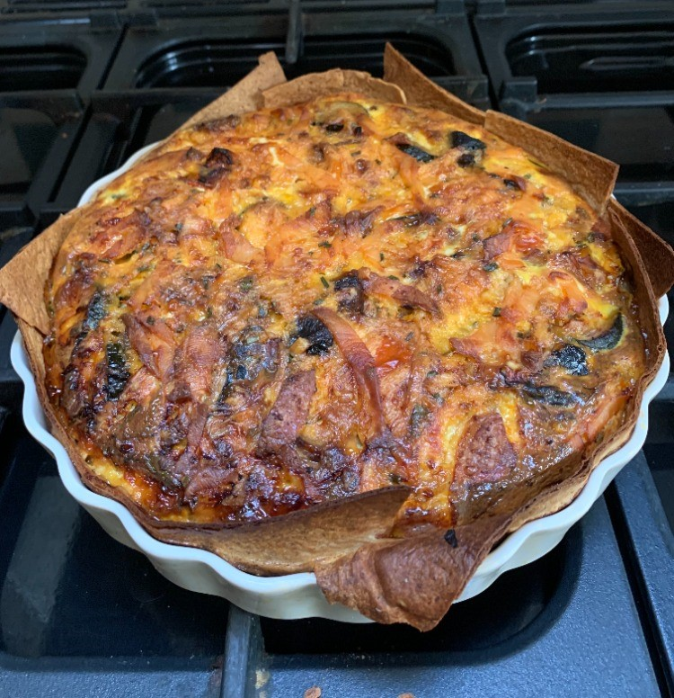

If you don’t have time to make pastry or prefer something lighter then this is a great recipe to try. This recipe can be adapted to your own tastes and preferences, and you can change the quantities of vegetables and salmon as required. The finished dish is a balanced mix of healthy carbs, high quality protein with omega 3 fatty acids (if using salmon), vitamins, minerals, antioxidants and fibre. Serve with a large mixed salad and sprinkle with toasted sunflower & pumpkin seeds for added crunch.

**Ingredients**

3-4 large wraps – wholemeal or half and half

Any vegetable combo – lightly steamed broccoli, roasted peppers, courgettes, onions, mushrooms,

Eggs – 4-5 large eggs depending on size of dish used

Milk – semi skimmed – use 50ml per egg used (200-250ml)

75g Cheese - grated – can use 30% reduced fat or regular cheddar

Olive or rapeseed oil for brushing wraps & sauteing / roasting vegetables

50g Smoked salmon, sliced into small pieces (optional)

Chives, salt & pepper for seasoning

**Instructions**

* Choose your vegetables. Chop and roast or saute vegetables in oven or pan with a little rapeseed or olive oil. Season with salt & pepper. Steam or lightly boil broccoli to soften. Set aside to cool.
* Brush the wraps (both sides) lightly with oil. Lay one whole wrap in the bottom of a round flan dish or spring-loaded cake tin. Cut 2 wraps in half and use to create the sides of the quiche ensuring there are no gaps and finally lay the final wrap over the first wrap. This should create the ‘pastry’ case for the filling.
* Mix the eggs and milk together – if you have a larger or deep dish then use 5 eggs and 250ml milk.
* Add either fresh or dried chives to the egg mix – however much you like. Season again.
* Arrange the cooked vegetables into the wrap lined dish, sprinkle the cheese evenly around and layer the smoked salmon on top.
* Carefully pour the egg mix over the top making sure it doesn’t spill over the sides of the wraps. It will look quite rustic!
* Place in the oven and cook on Fan 170 degrees (Gas 5) for 55-60 minutes or until set. If the top is browning too much place some tin foil over the top for the final 15 minutes.
* Leave in the dish for 10-15 minutes before slicing and enjoying. Can be enjoyed hot or cold.

**Nutrition**

Serves 4-6

For 4 servings each piece contains approx. (using 4 wraps, 30% reduced fat cheddar, 5 eggs, 250ml milk)

500 kcals

42g carbs

25g fat (6.5g Saturates)

27g protein